Did you know? The average water molecule stays nine days in the atmosphere!

Name_____________________________________________
Science TEKS: 3.11, 5.1, 5.2, 5.3, 5.4, 5.5, 5.6
Math TEKS: 5.11, 5.14, 5.15
Lesson Three:
Atmospheric Gases and Their Cycles

Overview. You have already learned a little about Earth’s atmosphere – its five layers, and some of its important properties like temperature and wind. Now we wonder, What types of gases make up the air around us? Today, we will learn about some of the important types of gases that make up the atmosphere. We will also learn about the cycles that enable those substances to move around the Earth and its atmosphere.

What are the five main gases that make up the atmosphere?

- _______________________
- _______________________
- _______________________
- _______________________
- _______________________

WATER CYCLE
Each of the words below is a process in the water cycle. Define each word and label it in the figure below.
- Evaporation:

2) Transpiration:

3) Condensation:

4) Precipitation:

5) Infiltration:
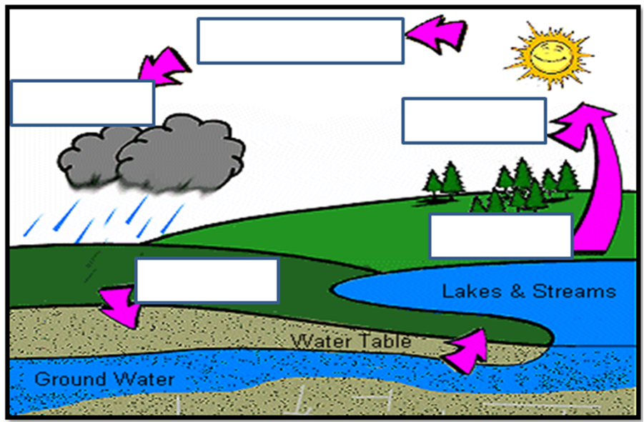
Credit: http://www.dnr.state.wi.us/org/caer/ce/eek/earth/groundwater/images/groundwater.gif
HUMIDITY
Humidity is a measurement of how much _____________________ is in the air.

Which instrument do we use to measure humidity?

CLOUDS

In what layer of the atmosphere do you find clouds?

Which types of clouds did you see outside today?

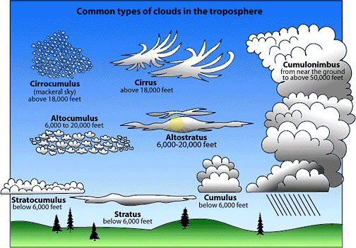
Credit: http://www.stmarysmedia.co.uk/jb01/project/images/cloudchart.gif

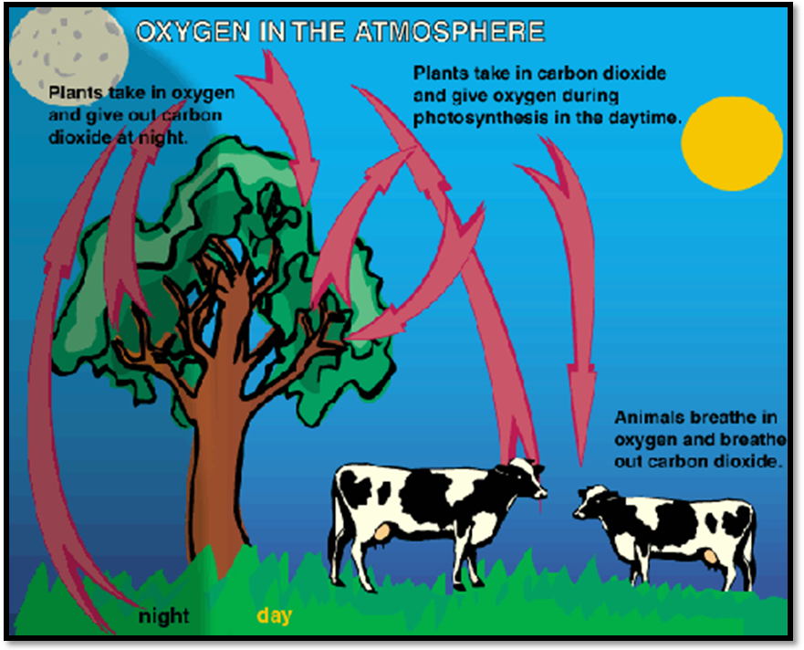

Oxygen Cycle
Credit: http://www.kidsgeo.com/geography-for-kids/0160-the-oxygen-cycle.php

What percent of the atmosphere is made up of oxygen?

Why is oxygen important to animals?

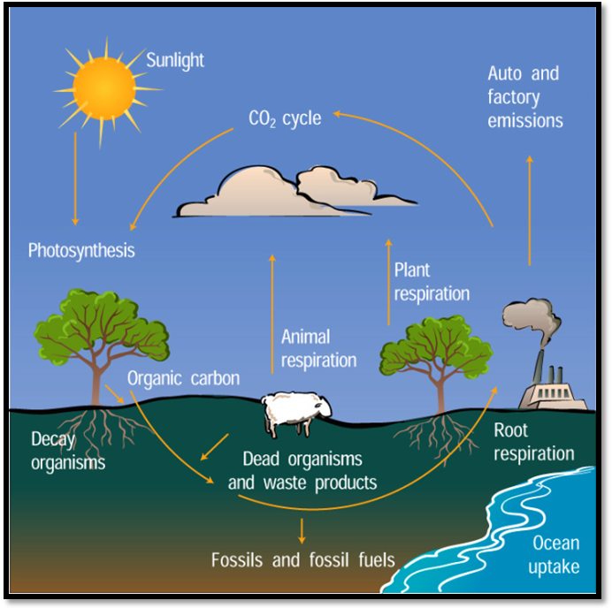
The Carbon Cycle
Credit: http://www.windows.ucar.edu/tour/link=/earth/climate/images/carboncycle_jpg_image.html&edu=elem
In which process do plants take carbon dioxide from the atmosphere?

In which process do plants, animals, and roots release carbon dioxide into the atmosphere?
How do autos and factories affect the carbon cycle?

What did you find cool or
surprising that you learned about
the atmosphere today?
Describe a few new facts that you learned.
____________________________________________________________________________________________________________________________________________________________________________________________________________________



